**Access Control List Report**

**Asland Taylor**

**8/4/2023**

**ITT-216**

In the realm of networking, where data flows incessantly through complex networks, the protection of sensitive information and the assurance of secure communication have risen to the forefront of concerns. Within this context, Access Control Lists (ACLs) emerge as pivotal elements of network security infrastructure. ACLs function as digital gatekeepers, meticulously managing the flow of data packets within networks. This detailed report delves into the nuances of ACLs, shedding light on their classifications, applications, advantages, limitations, strategic placement, and the profound impact they wield on traffic control and network strengthening.

At the core of ACLs lies a dual categorization, encompassing Standard and Extended IP ACLs. Standard IP ACLs epitomize the fundamental essence of traffic filtering, operating on the principle of source IP addresses. Falling within the ranges of 1 to 99 and 1300 to 1999, these ACLs prioritize simplicity. Their primary role revolves around granting or denying traffic based on specific source IP addresses. Strategically positioned at the network's edge, these ACLs act as sentinels, meticulously examining inbound and outbound traffic as it interacts with external networks. The elegance of standard IP ACLs lies in their user-friendly configuration process, enabling organizations to swiftly establish rules to permit or restrict traffic from designated source IP addresses, effectively curbing unauthorized access. Nonetheless, this seemingly refined solution grapples with limitations when faced with the complexities of intricate filtering. The absence of provisions to filter based on destination IP addresses, protocols, or port numbers diminishes their utility in intricate network setups.

Extended IP ACLs elevate the concept of traffic filtering to a higher level of sophistication. Encompassing numeric ranges of 100 to 199 and 2000 to 2699, these ACLs transcend the realm of source IP addresses. They take into account source and destination IPs, protocols, and port numbers, thereby empowering network administrators to craft nuanced access control policies that align with diverse traffic profiles. The standout feature of extended IP ACLs is their capacity to accommodate multifaceted filtering criteria, granting administrators a versatile toolkit to craft precisely tailored security policies. However, this prowess comes at the cost of complexity. The multifaceted nature of extended IP ACLs necessitates a heightened level of configuration expertise and operational acumen, making them more suitable for environments equipped with sufficient technical resources (Margaret Rouse et al. (2012)).

The strategic positioning of ACLs within the network infrastructure is pivotal in determining their effectiveness. Both categories of ACLs achieve optimal results when situated in close proximity to the entry and exit points of network segments. Placed strategically at these junctures, ACLs function as vigilant gatekeepers, proactively intercepting data traffic as it embarks on its journey through the network. This positioning empowers ACLs to enforce access controls from the very inception of data movement, bolstering network security by mitigating potential risks.

In the realm of networking, where data flows ceaselessly through intricate networks, the imperative of safeguarding sensitive information and ensuring secure communication has surged to the forefront. In this context, Access Control Lists emerge as vital cornerstones of network security infrastructure. Acting as virtual gatekeepers, ACLs meticulously govern the passage of data packets within networks. This comprehensive report delves into the nuances of ACLs, illuminating their classifications, applications, advantages, drawbacks, strategic positioning, and the profound ramifications they exert on traffic management and network reinforcement.

At the heart of ACLs lies a dual classification, encompassing Standard and Extended IP ACLs. Standard IP ACLs encapsulate the fundamental essence of traffic filtering, functioning based on source IP addresses. Falling within numerical ranges of 1 to 99 and 1300 to 1999, these ACLs prioritize simplicity. Their primary role revolves around permitting or denying traffic rooted in specific source IP addresses. Positioned strategically at the network's periphery, these ACLs serve as sentinels, meticulously scrutinizing incoming and outgoing traffic as it interacts with external networks. The elegance of standard IP ACLs resides in their user-friendly configuration process, enabling organizations to promptly establish rules to grant or block traffic from designated source IP addresses, effectively curbing unauthorized access. However, this seemingly streamlined solution encounters limitations when grappling with the intricacies of more sophisticated filtering scenarios. The absence of provisions to filter based on destination IP addresses, protocols, or port numbers diminishes their utility in intricate network configurations.

Extended IP ACLs elevate the concept of traffic filtering to a heightened plane of sophistication. Encompassing numeric realms of 100 to 199 and 2000 to 2699, these ACLs transcend the realm of source IP addresses. They factor in source and destination IPs, protocols, and port numbers, thereby empowering network administrators with the ability to craft nuanced access control policies that align with diverse traffic profiles. The crowning achievement of extended IP ACLs lies in their capacity to accommodate multifaceted filtering criteria, providing administrators with a versatile toolkit to precisely shape security policies. However, this capability comes with added complexity. The multifarious nature of extended IP ACLs demands a heightened level of configuration expertise and operational acumen, rendering them more suitable for environments equipped with ample technical resources (Margaret Rouse et al. (2012)).

The strategic placement of ACLs within the network infrastructure is pivotal in determining their effectiveness. Both categories of ACLs achieve optimal results when positioned in close proximity to the entry and exit points of network segments. Strategically positioned at these junctures, ACLs function as vigilant gatekeepers, proactively intercepting data traffic as it embarks on its network traversal. This strategic placement empowers ACLs to enforce access controls from the inception of data movement, enhancing network security by mitigating potential risks.

References

*Configure and filter IP access lists* (2022) *Cisco*. Available at: https://www.cisco.com/c/en/us/support/docs/security/ios-firewall/23602-confaccesslists.html (Accessed: 04 August 2023).

Margaret Rouse *et al.* (2012) *Access control list*, *Techopedia*. Available at: https://www.techopedia.com/definition/24766/access-control-list-acl (Accessed: 04 August 2023).

*CCNA routing & switching ICND1 100-105 course* (no date) *NetworkLessons.com*. Available at: https://networklessons.com/cisco/ccna-routing-switching-icnd1-100-105 (Accessed: 04 August 2023).

PG1 P4

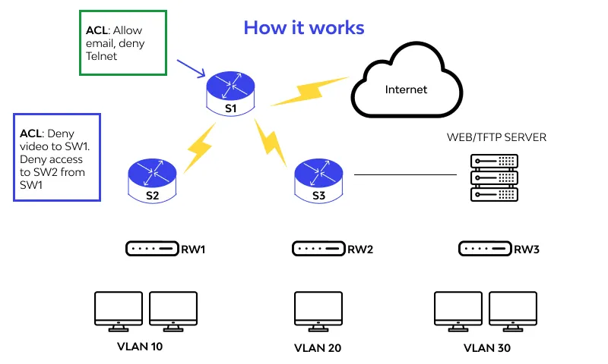

PG1 P3

